

**SCHOOL OF ELECTRICAL ENGINEERING**

**Temperature and Light Monitoring System**

*A project report submitted for fulfilling the course requirement of S.Y. B.Tech*

*PC 1*

Environmental Science CH 201

On

The 5th October 2018

By: Anjumfiza Shaikh SETB102 S187211

Krushna Garkal SETB113 S187020

Puja Pardhi SETB127 S187006

Rutika Utage133 SETB133 S187153

**INTRODUCTION:**

**Temperature Monitoring:**

* In today’s modern world, most of the products that we produce have a very crucial factor affecting it i.e. temperature. Starting from the traditional crops to the artificial ones in food industries, from drugs to chemicals manufactured in the pharmaceutical industries, all of them need the right amount of temperature to be maintained for manufacture which is why the monitoring of temperature constantly is an indispensable part of these sectors.
* Our homes too have thermostat installed which monitor and regulate the temperature. Maintaining the right temperature is required for having a healthy growth of plants. If the right temperature is not maintained, the plants will die.

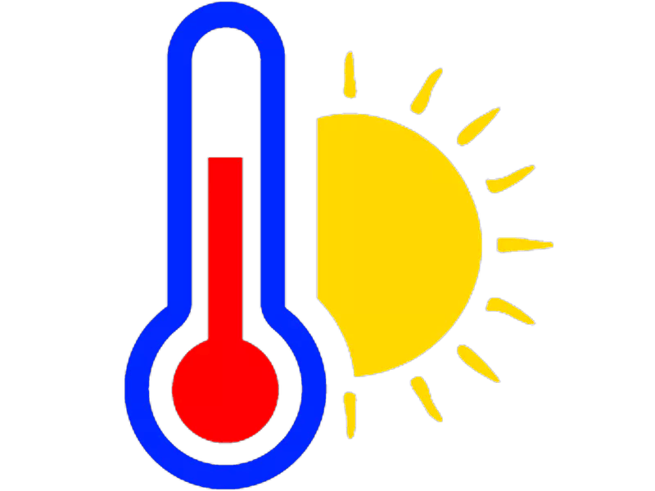  
**Problems faced in agricultural sector:**

* Climate change is expected to negatively affect both crop and livestock production systems in most regions, although some countries may actually benefit from the changing conditions. Overall, productivity levels are expected to be lower than without climate change – due to changes in temperatures, crop water requirements and water availability and quality.
* Climate change is exacerbating the challenges faced by the agriculture sector. Climate change-induced increases in temperatures, rainfall variation and the frequency and intensity of extreme weather events are adding to pressure on the global agriculture system – which is already struggling to respond to rising demands for food and renewable energy.
* The changing climate is also contributing to resource problems beyond food security, such as water scarcity, pollution and soil degradation. As resource scarcity and environmental quality problems emerge, so does the urgency of addressing these challenges.

**Light Monitoring:**

We all know that plants require sunlight for their healthy growth. However, at times we may not be able to keep a track of it or maybe we are not sure if our plants are getting enough sunlight.

In this project, we will build a system so that we could monitor the light our plants get and send the data to Bolt Cloud. In fact, this product is commercially available by Xiaomi . But as makers, we shall build this product on our own.

At the end of the project, we will be able to collect the values indicating intensity the of the light and plot them over a line graph.



**LITERATURE REVIEW:**

The sources which were referred to for studying the topic were mostly websites , videos and blogs . The five most useful sites/blogs were:

Electronics Hub Blog

Modern Agriculture Blog

‘The Urban Farmer’ by Curtis stone

IEEE- ieeexplore.ieee.org/document/5697157

omega.com/kwbld/temperaturemonitoringsystem.html

**The Project:**

Introduction to the present work:

**The work done:**

# Temperature Monitoring System

**Step 1: Connecting LM35 to Bolt**

Follow the connections as mentioned below. It as easy as saying 1,2,3. You can refer the pin out of the LM35 sensor as shown below,

1. Make sure you have not powered on your Bolt Module white connecting the circuit. This will ensure that in case we make any mistake, it will not short circuit your device. Switch off the power if it is connected.
2. Connect the VCC pin of LM35 to 5V pin of the Bolt device.
3. Connect the GND pin of LM35 to GND pin of the Bolt device.
4. Connect the analog output pin of LM35 to A0 (analog input) pin of the Bolt device.

[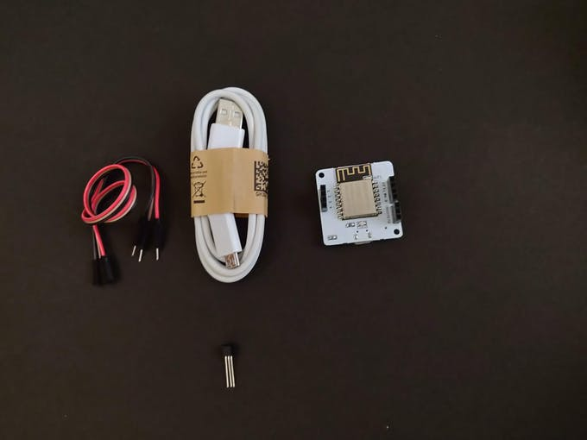](https://files.readme.io/2b6bbbe-7.jpg)

Components

**Light Monitoring for Plants**

**Building the circuit**

1. Make sure you have not powered on your Bolt Module while connecting the circuit. This will ensure that in case we make any mistake, it will not short circuit your device. Switch off the power if it is connected.
2. Connect one end of the LDR to the A0 (analog) pin of the Bolt device and other ends of the LDR to the 5V pin of the Bolt as shown in the image below.
3. Connect the 10K ohm resistor between the GND and A0 pin of the Bolt so that LDR and the resistor form a series connection.
4. Now your circuit is ready. You may power on your device.

Components

*[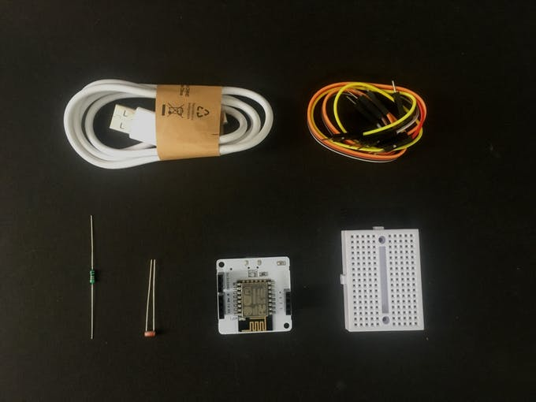](https://files.readme.io/0feeec2-1.jpeg)*

*LDR with Breadboard*

[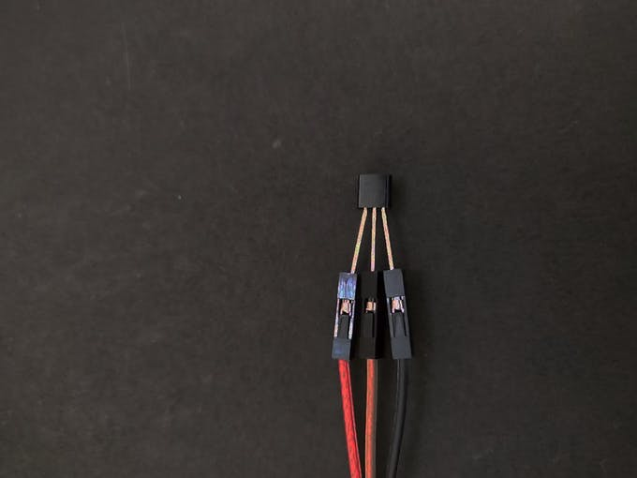](https://files.readme.io/f6c650d-8.jpg)

*Connecting LM35 to jumper wires*

[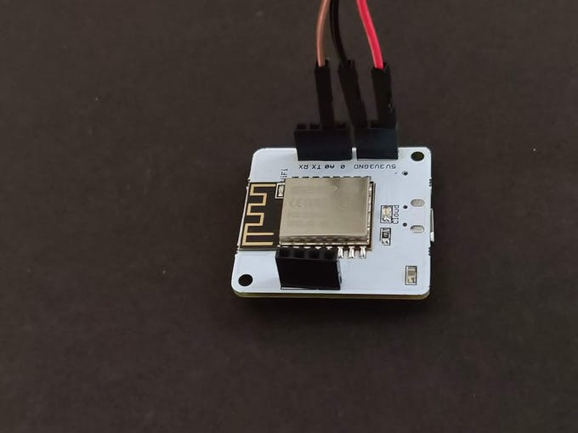](https://files.readme.io/18d28c1-9.jpg)

*Connecting jumper wires to Bolt*

[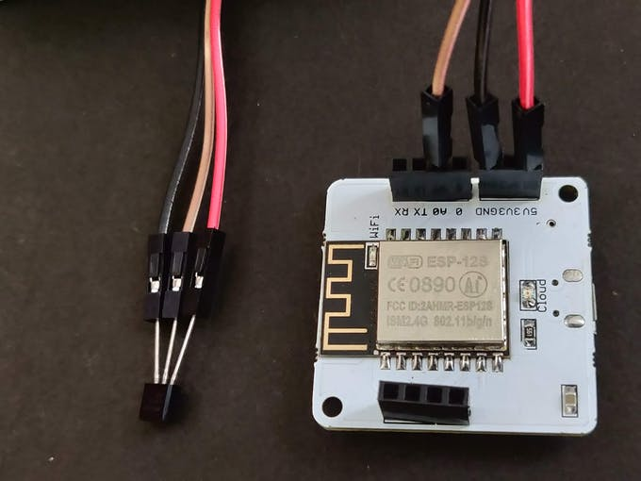](https://files.readme.io/bc4efe5-10.jpg)

*LM35 connection to Bolt*

[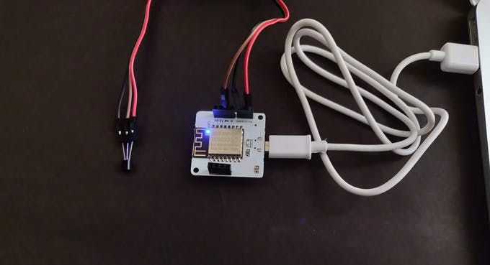](https://files.readme.io/abaea54-11.jpg)

**NOTE: Make sure connections are made properly.**

Congratulations, we are done with the hardware. See how simple it was. Let's move on to the next step.

**Step 2: Connecting Bolt to Cloud**

To check if it is connected to cloud, have a look at the Green coloured Cloud LED on the Bolt WiFi Module. It should be glowing.

Follow the steps in this project to setup the device and to connect your Bolt device to the Bolt Cloud.: Setting Up the Bolt WiFi Module

Now that our Bolt is active, we are just a step away from completing the system.

**Step 3: Visualising the Data (Plotting Graph) on the Bolt Cloud**

Now we need to visualise the temperature data on the Bolt cloud. For this create a FREE account on cloud.boltiot.com if you have not already.

Just follow these simple steps:

1. Login into https://cloud.boltiot.com  and click on the 'Product' tab.

[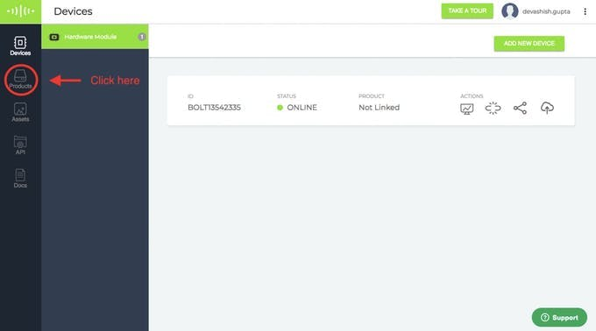](https://files.readme.io/264dc93-12.jpeg)

*Go to Product tab*

1. Create a new product for your temperature monitoring system. Products are created once and can be used for multiple Bolt devices. This ensures scalability for your IoT products you build on Bolt.

[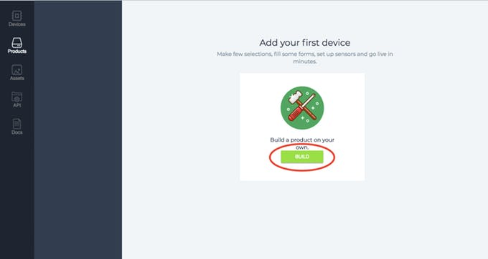](https://files.readme.io/4d907ce-13.jpeg)

[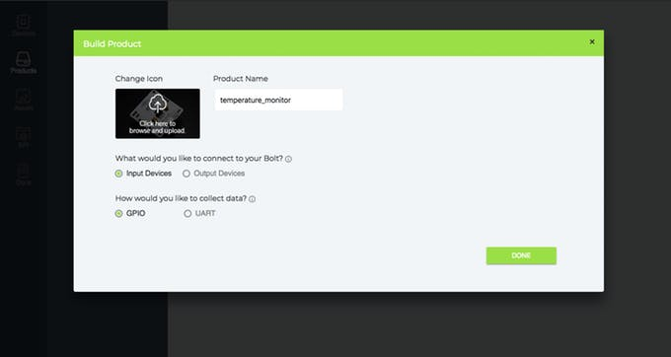](https://files.readme.io/a2dd068-14.jpeg)

1. Click on Configure this product to configure the product. This will open a popup where you can configure your products hardware setting and write the software code.

[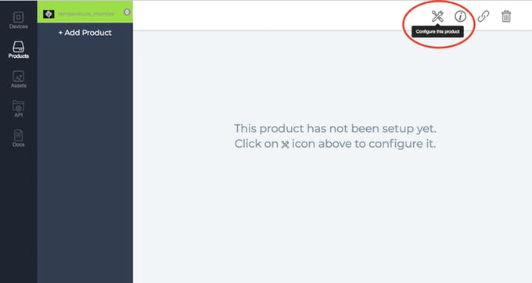](https://files.readme.io/12ed1bd-15.jpeg)

1. Click on the "A0" pin of the Bolt and give it a name in the right side naming section. Finally, click on the "Save" icon to save your change and wait for the page to reload.

[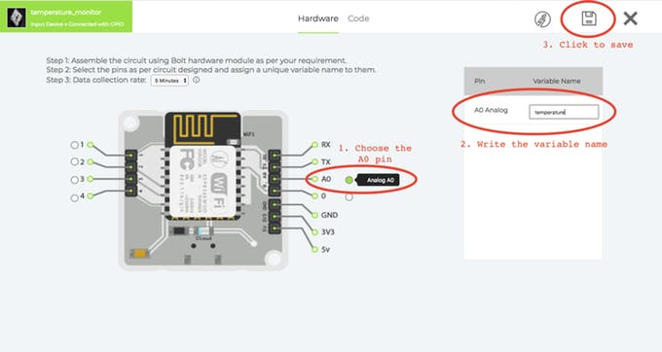](https://files.readme.io/5633b85-16.jpeg)

1. Click on the Code Section then click on the "Import Code example" icon as shown below. This will open a pop-up menu where you can choose the variable. In this code since we have connected only one sensor, you could simply choose the only variable in the dropdown and press OK.

[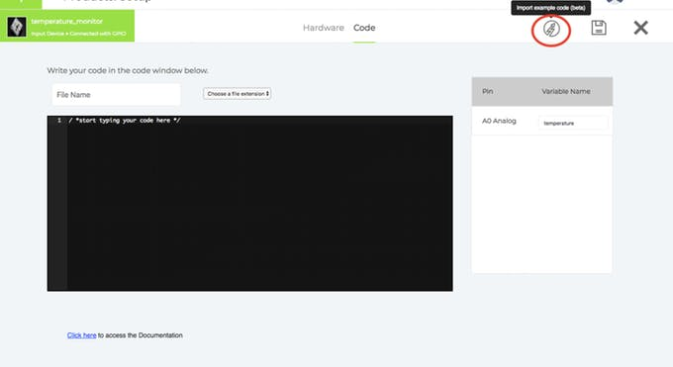](https://files.readme.io/2445ceb-17.jpeg)

[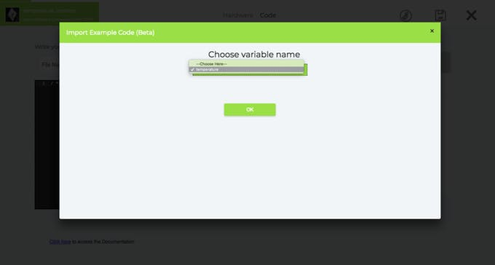](https://files.readme.io/cbf747d-18.jpeg)

1. Now you will be presented with a variety of graphs to choose from. Choose the "Line Graph" and then click on the "Import" button.

[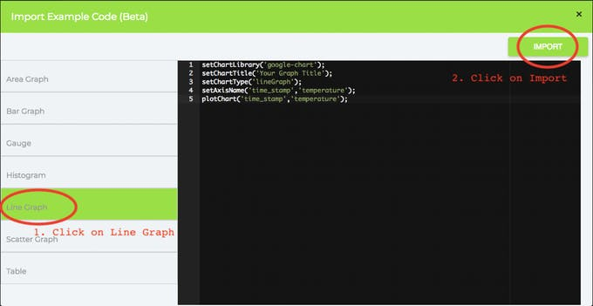](https://files.readme.io/308aad5-19.jpeg)

Now let me explain each line of the code so that you could make suitable changes as you wish.

**setChartLibrary** function sets the Data Visualisation Library you would use. The most commonly used one on Bolt Cloud is the Google Library. However, you could use any other JavaScript or HTML code here to visualise the data.

**setChartTitle** function sets the Title of the Chart/Graph. Give a suitable name for your graph here which will be shown in the heading of the page. This is different from the name of the code file.

**setChartType** function is where you choose which type of chart you want i.e. Line Graph, Bar Graph etc.

**setAxisName** will set the name for the X Axis and Y Axis

**plotChart** is where you choose which variable you want to choose in your chart.

1. Next, we will need to convert the raw sensor value received to degrees. For this, we will need to multiply the raw sensor value with 0.0977. An explanation for this is given towards the end of the project.

For multiplication, we use the 'mul' function. Just enter the line mul(0.0977) before the plotChart function. This will multiply the sensor value received with the multiplication factor.

**Converting Temperature reading to Fahrenheit**

The formula for converting temperature from Celcius to Fahrenheit is,  
F = 1.8*C + 32

So, to show the reading in Fahrenheit, we will need to multiply the sensor reading by 1.8 and add 32 to it.  
The code for this, will look similar to,

setChartLibrary('google-chart');  
setChartTitle('Your Graph Title');  
setChartType('lineGraph');  
mul(0.0977); // convert to Celcius  
mul(1.8); // multiply by 1.8  
add(32); // add 32 to get the temperature in Fahrenheit  
plotChart('time_stamp','temperature');

[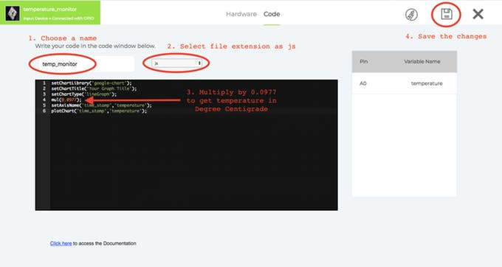](https://files.readme.io/1a8f1d8-20.jpeg)

1. Now write the file name for your code and choose the file extension as "js".

Finally, click on the "Save" icon to save the changes to the product.

1. Now, our product configuration is ready, but we need to "link" a bolt device to the product so that the Bolt can actually start sending temperature data.

[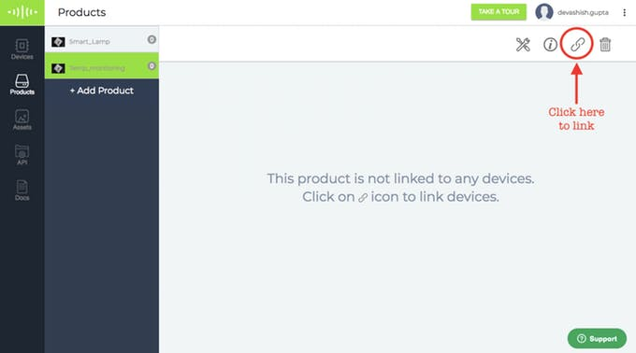](https://files.readme.io/5e04601-21.jpeg)

*Click on the link tab*

[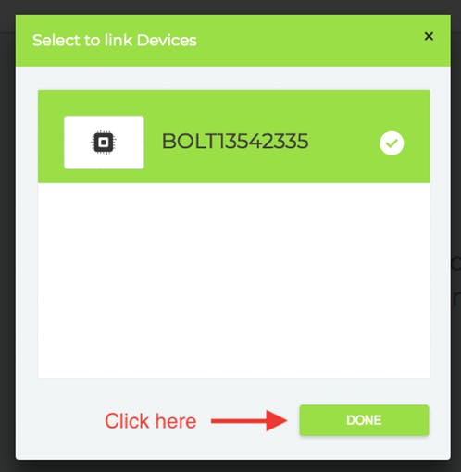](https://files.readme.io/edb0373-23.jpeg)

*Click Done*

[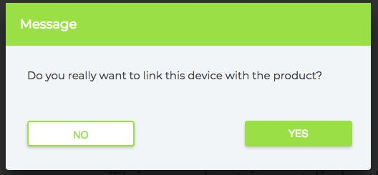](https://files.readme.io/88f8af5-24.jpeg)

*Click Yes*

1. Now, we need to deploy the code to the Bolt device. Deploying will transfer the code and configuration to the Bolt device. Its similar to programming an hardware device like an Arduino. Except here the programming happens over the internet.

[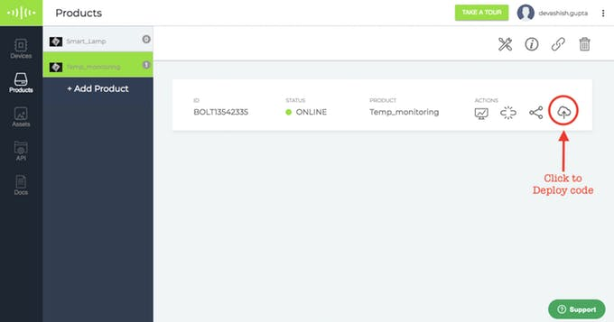](https://files.readme.io/c3564b8-25.jpeg)

1. That's great you say. Now how do I see the temperature? For this, you will need to click on the "Computer Monitor" icon on your Bolt device.

[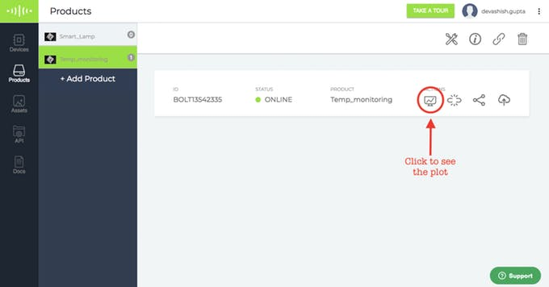](https://files.readme.io/2e8fd39-26.jpeg)

*View the plot*

This will open up a new page which will have a graph. Every 5 minutes, the Bolt will send a temperature reading to the Bolt Cloud.

If you see a blank graph, wait for a few minutes for the device to send the sensor reading to the cloud. If you don't want to wait then you could press the push configuration button again. Every time you click on that button it sends the current sensor value to the graph. It's a manual method that can be used for testing

**Working principle**

The working principle of the system is quite easy. Let understand it.

Here in our system, LM35 is the sensor that senses the temperature of its environment and based on it's value it generates an analog output voltage. This analog voltage produced by the LM35 is then given as input to the Bolt A0 pin. The Bolt then converts the analog value into a 10 bit digital value that varies from 0-1023. This digital data is sent to the cloud via Bolt device.

Hence, while plotting the temperature, it is required to convert the raw sensor values into the actual temperature value, which is done using the given formula:

*temp = (analog_value*100)/1023*  
The converted digital data is then plotted for visual representation.

The Final Project:

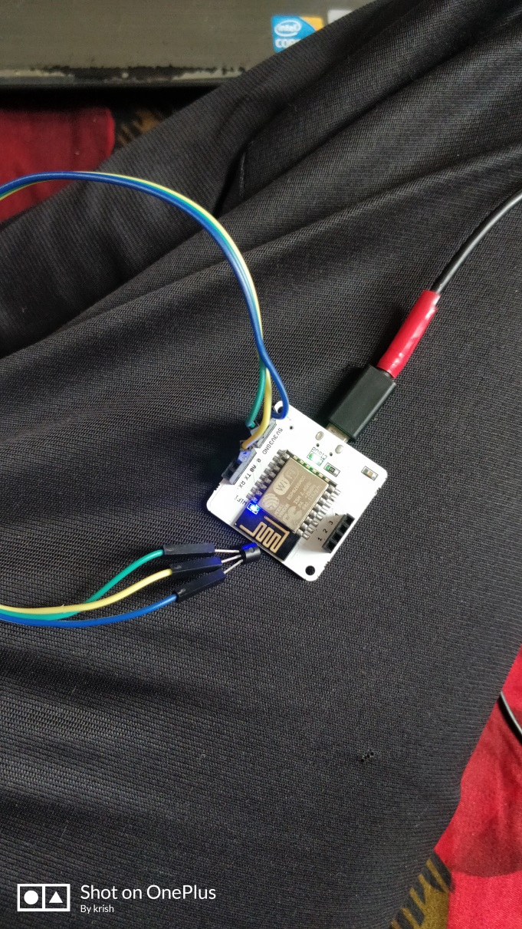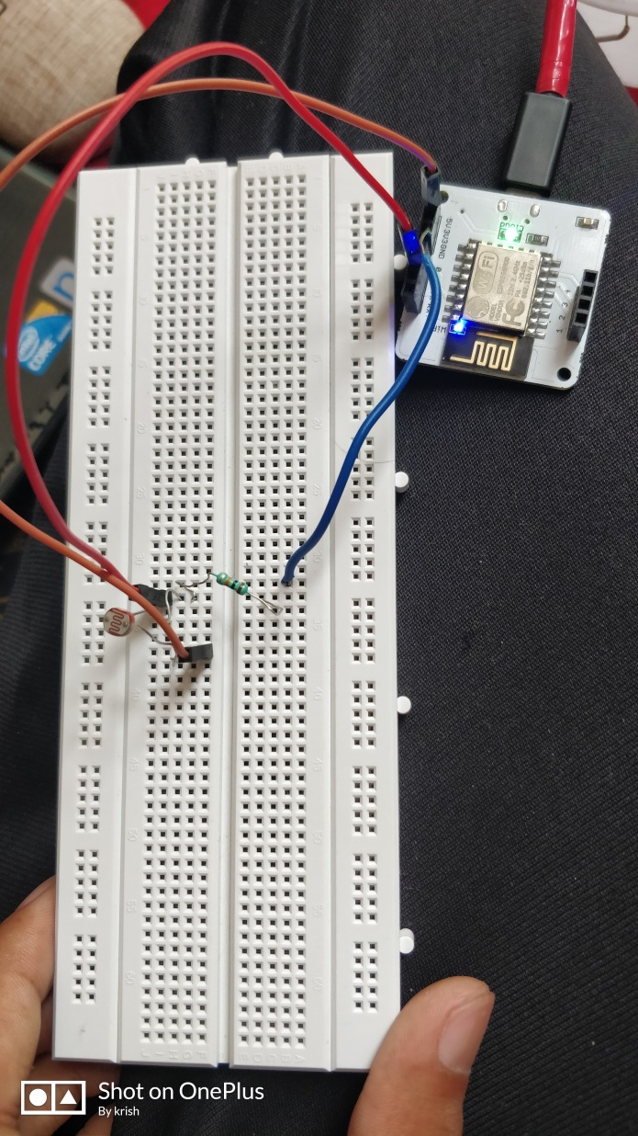

**Output Plot**

As the cloud collects more data, the graph gets plotted and you will be able to see the temperature variations across the day.

**Output Plot**

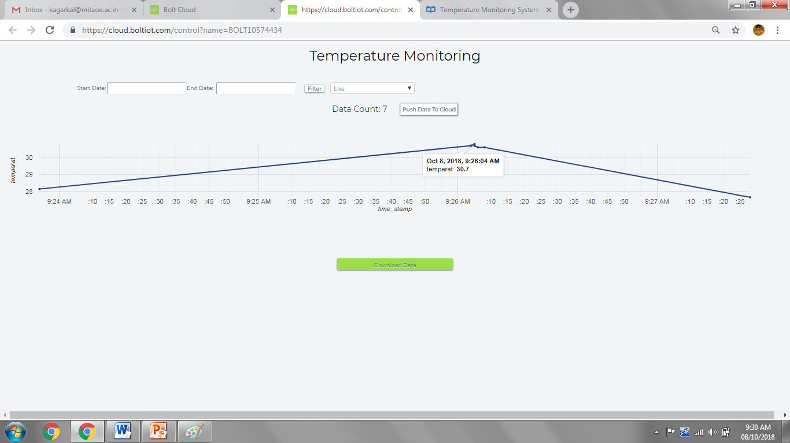

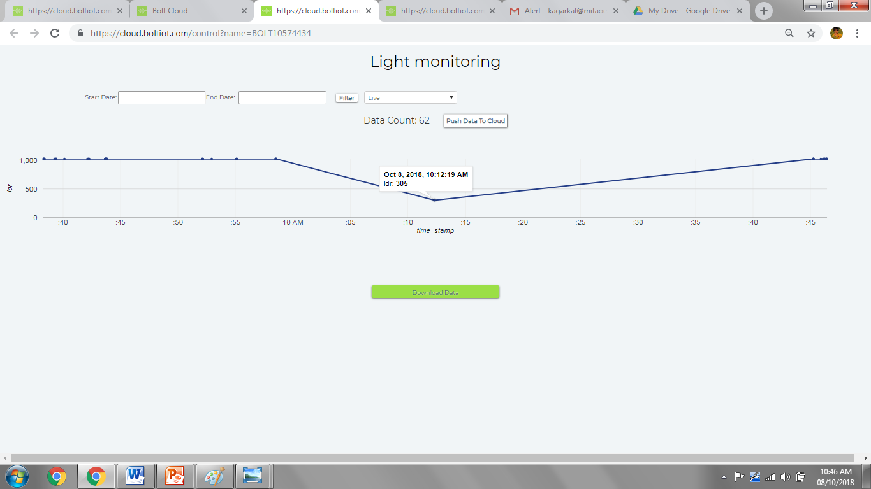

Benefits of the project: The farmers are now able to view the changes taking place in the temperature and how is the LED lights operating accordingly.

**Applications:**

**Food Industry**:It’s easy to see why temperature control is essential in this industry, but temperature monitoring, especially wireless temperature monitoring, is imperative because monitoring can prevent a small issue from becoming a disaster.

**Data** **Centers**: Is temperature monitoring that critical for an IT department ?

Yes. Overheating and other environmental issues are major problems for a company’s data center or server room. Costly equipment and computer hardware can easily malfunction or be severely damaged by overheating or sometimes even severe cold. The cost of the equipment and the sensitivity of the data housed in server rooms is too great to be left to chance. Temperature and other environmental factors like humidity and water leaks must be monitored continually to prevent damage.

**Transportation**: This is another industry that might not readily come to mind when you think of temperature monitoring, but it is vital, especially for the transport of perishable goods. Regulating temperature in-transit can be difficult, and it can be time-consuming to constantly check the temperature of your goods. Our wireless temperature monitoring systems make in-transit monitoring easy with audible records for on-demand visibility and quality assurance. These monitoring systems can save you money over traditional in-transit and one time recorders while providing more accurate and secure monitoring.

**Healthcare:** Involved in a life-saving work, those in the healthcare industry – both in pharmaceuticals and healthcare facilities – can’t take a chance with medication temperatures. Our remote temperature monitoring systems are ideal for those in life sciences because these systems are accurate, reliable, and secure. Medical refrigerators and laboratories need to constantly monitor the temperature of medications, clinical trials, research, and vaccines to ensure patient safety and prevent product loss.

**Future:**

To save water resources as a result of smart management.

Industries will work without any fear of accidentals fires

Digital technology will provide perfect alternative to manual methods. Automated, wireless monitoring continuously captures data through sensors within fridges, freezers and other equipment, and then uploads it to the cloud, where managers can see it, wherever they are. If temperature readings move outside predetermined parameters alerts can be sent to staff, at any time, day or night, through warnings on local PCs, email and text messages

This project can then be extended to predict the future sensor values via Machine Learning over the Bolt Cloud.

**CONCLUSION:**

The temperature , intensity of light sent to the cloud by specific time interval. Proper values are set according to the type of plant .

Proper graphs of variations are obtained in these parameters using Visualization data from cloud

Any undesirable change in climatic conditions is notified immediately

Now industries are pretty much secure from accidents happen due temperature changes.

Plants are protected fromadverseclimatic conditions**.**

**Refrences:**

* [**https://ijcsmc.com/docs/papers/August2015/V4I8201560.pdf**](https://ijcsmc.com/docs/papers/August2015/V4I8201560.pdf)
* [**https://www.researchgate.net/publication/316448621/download\**](https://www.researchgate.net/publication/316448621/download/)
* [**https://www.scribd.com/document/334848424/Smart-Greenhouse-System**](https://www.scribd.com/document/334848424/Smart-Greenhouse-System)